13.2.17 Newsletter
Woodlands C. of E. Primary School
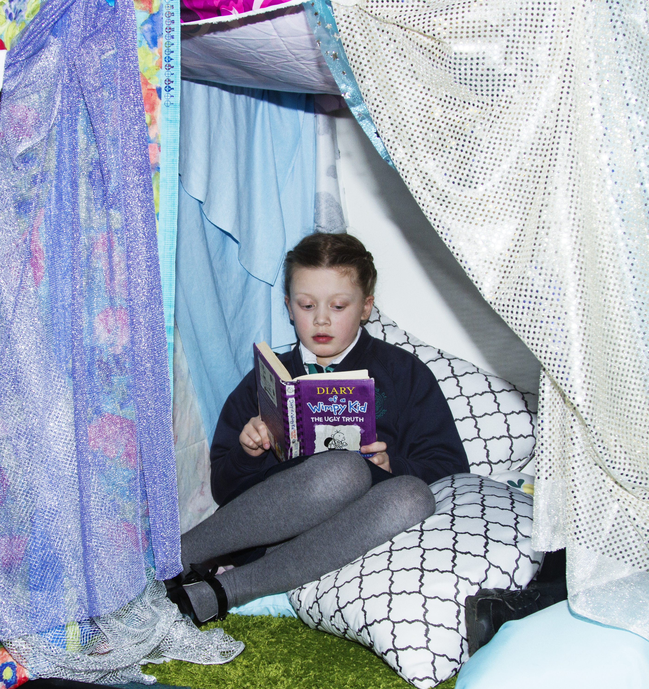

Upcoming Events

World Book Day
Thursday 2nd March
Dress up as your favourite book character

Half term
Week commencing 20th February

Teacher Training day
Monday 27th February (school closed to pupils)

W.C 3rd April
Decorate an orange (instead of an egg!) in aid of Muscular Dystrophy – more details later.

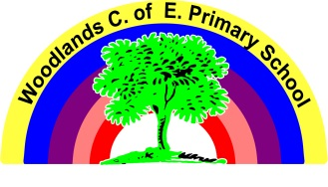

www.woodlandsprimary.org.uk T: 01274 678385
Scholastic Book Fair
All this week we have the Scholastic book fair in school.
There are many great books to buy as well as other bits and bobs, all commission made will be used towards purchasing great new resources for the children in school.
The Book fair is open every night straight after school until 3.45pm in the hall. We shall have the book fair open throughout Wednesday evening at Parents evening.

Parents Evening
If you have not yet made an appointment to see your child’s teacher please do so. Parents evening is Wednesday this week, if the teacher is unable to give you a suitable appointment another time can be arranged.

World Book Day Thursday 2nd March
Woodlands is pleased to be taking part in World Book Day on Thursday 2nd March. Children can come dressed as their favourite character for the day. We shall celebrate the day in school with a focus on particular chosen book titles.

Old Shirt Requests
As we have a lot of creative work coming soon, in the curriculum and not a lot of aprons in school, please donate any men’s shirts and t-shirts that are no longer wanted as these make ideal cover ups for the children when taking part in messy activities. Thank you.

February Half term holiday
School closes at 3.05pm on Friday 17th February (Dance after school club will still run as normal) and reopens to pupils on Tuesday 28th February at 8.45am (Breakfast club doors shall open as normal at 7.45am). There is a teacher training day on Monday 27th February.

Nut Allergy
Please note we have a pupil and a member of school staff both who have a nut allergy, therefore please do not send any items in lunchboxes which contain nuts. Thank you.

