27.3.17 Newsletter
Woodlands C. of E. Primary School
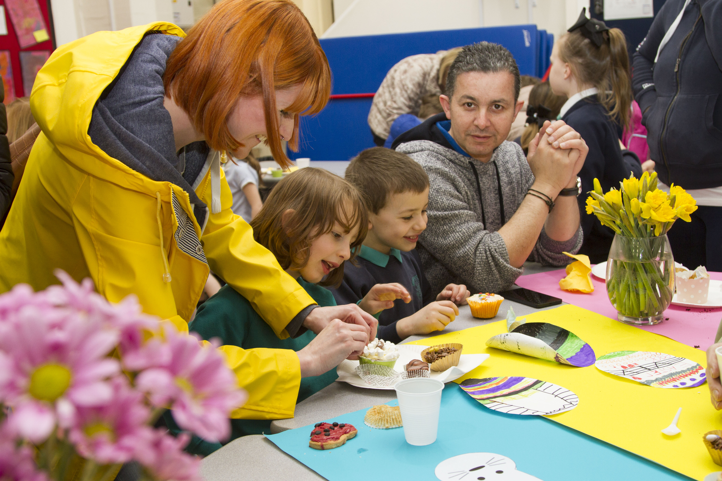

Upcoming Events

Easter break
School closes Friday 7.4.17
Reopens 24.4.17

W.C 3rd April
Decorate an orange (instead of an egg!) in aid of Muscular Dystrophy – more details later.

Bradford City Penalty shoot out day
Tuesday 4th April (PE kits needed)

www.woodlandsprimary.org.uk T: 01274 678385
Decorate an Orange!
All pupils are invited to ‘Decorate and Orange’ (instead of decorate an egg’, so that we can raise further funds for Muscular Dystrophy.
All decorated oranges to arrive in school from Monday 3rd April up until Thursday 6th April. Please send in £1.50 to enter and make sure your orange has a name on!
There will be a Prize for Early Years & KS1 and a prize for KS2, criteria is the most imaginative/creative idea.

Saying Goodbye to Mrs Dennison
Mrs Dennison is leaving school at the end of this term (Wednesday 5th April is her last working day in school).
She will be greatly missed and we thank her for the 10 years she has worked hard and supported all that we do in school.

Dress Down Friday for Easter
Friday 7th April is a non-uniform day in school, we ask that pupils bring a donation of an Easter egg for the raffle in the afternoon please.

Raffle Tickets
Please return monies for Raffle tickets by Wednesday 5th April, don’t worry if you can’t find the raffle ticket strip, as Mrs Holroyd has the other half named in school.

Bradford City Penalty Shoot Out
Bradford City Football Club Community Foundation are visiting our school to carry out a sponsored penalty shootout on Tuesday 4th April.

Administrative Assistant post
School currently has a vacancy for an administrative assistant. The vacancy is being advertised through Kirklees jobs vacancies (online), and packs can be requested from Miss Webster.

Easter Coffee Afternoon Fundraiser
Our Easter coffee afternoon was very well supported, thank you very much for all donations of cakes and visitors! We raised a fabulous £318.08!

Kirkwood Hospice Boxes
The children will be bringing home a small collection box in aid of Kirkwood Hospice. Please give generously and then return the box to school no later than Friday 28th April. Thank you for your support.

